
LjunggrenAudio RYO NAND/AND
Discrete Resistor-Transistor Boolean Logic in 4hp

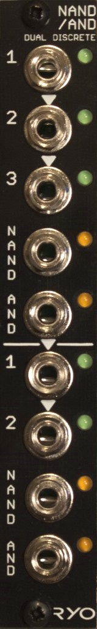

- directly modelled on RTL digital logic gate designs pioneered in the 1950s used in computing equipment throughout the 50s and 60s.
- can be used as audio waveshaper/distortion.
- The NAND/AND module can be patched as:
- two NOT gates,
- one NOT gate and one 2- or 3-input NAND/AND gate,
- one 2-input NAND/AND gate and one 2- or 3-input NAND/AND gate, or,
- one 4-input NAND/AND gate.
- All analogue circuitry.
- slim 4HP footprint.
- compact 45mm Depth (with power cable attached).
- low power draw: 28mA +12V / 0mA -12V / 0mA +5V.
- Works for audio as well as CV.
- Fast responding CV inputs allow up to audio rate operation.
- The inputs on gate one are normalized in a 1>2>3 fashion for patching.
- The input on gate two are also normalized 1>2,
- the AND out from gate one is normalized to input 1 on gate two.
- signal indicator LEDs on every input and output.
- can accept input signal to +10V peak.

downloads
* user manual
* quickstart guide
* assembly guide
* hi-res schematic
* datasheet
* BOM

